How to Pray the Bible

An Exercise in Reading Scripture and
Praying What the Spirit Brings to Mind

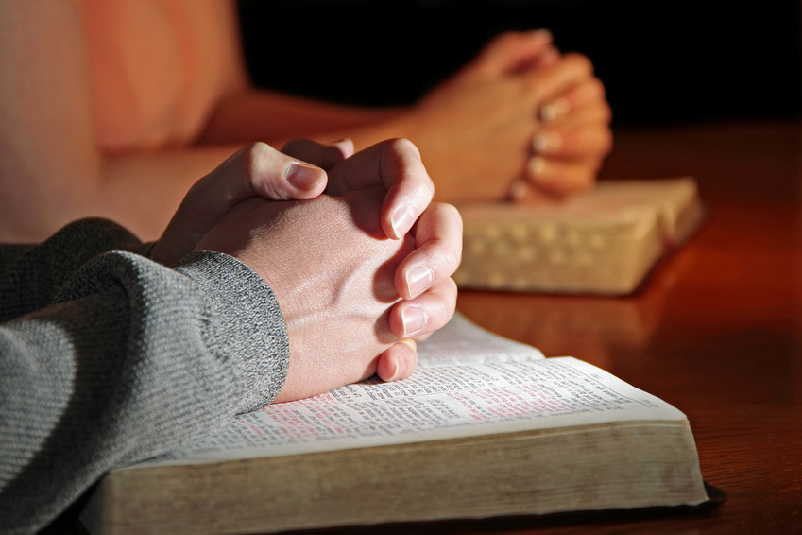

Based on a method outlined in the book
Praying the Bible by Donald S. Whitney

Pastor Greg Burlile
Darby Creek Church
Galloway, Ohio
Email: gregb@darbycreek.org
twitter: @gregburlile

* An Example in How to Pray the Bible
There are two columns of text below. On the left you will see the text of Psalm 32 in the New Living Translation. On the right you will find an example of how the words of Psalm 32 might prompt a believer to pray.

Important!!! – Praying the Bible is NOT the same as studying the Bible or interpreting the Bible. In this method of prayer, we are allowing the Holy Spirit to use the Bible text to bring things to our mind to pray about. Many of those things will be a proper application or implication of the Scripture text. Some of the prayers prompted from this Psalm may be sparked by just a single word that was read and may have nothing to do about the original context. Our task here is to pray, not exegete the passage. Paul tells to be anxious about nothing and to pray about everything (Philippians 4:6-7) so there is nothing we can’t pray about and take the Lord regardless of what Bible passage brings that prayer topic to mind.

Psalm 32 NLT
1 Oh, what joy for those
whose disobedience is forgiven,
whose sin is put out of sight!
2 Yes, what joy for those
whose record the Lord has cleared of guilt,
whose lives are lived in complete honesty!
3 When I refused to confess my sin,
my body wasted away,
and I groaned all day long.
4 Day and night your hand of discipline was heavy on
me. My strength evaporated like water in the
summer heat.

5 Finally, I confessed all my sins to you
and stopped trying to hide my guilt.
I said to myself, “I will confess my rebellion to the Lord.”
And you forgave me! All my guilt is gone.
6 Therefore, let all the godly pray to you while there is
still time, that they may not drown in the floodwaters
of judgment.

7 For you are my hiding place;
you protect me from trouble.
You surround me with songs of victory.
8 The Lord says, “I will guide you along the best
pathway for your life.
I will advise you and watch over you.
9 Do not be like a senseless horse or mule
that needs a bit and bridle to keep it under control.”

10 Many sorrows come to the wicked,
but unfailing love surrounds those who trust the Lord.
11 So rejoice in the Lord and be glad, all you who obey
him! Shout for joy, all you whose hearts are pure!

A Sample of What Might Be Prayed

Father, thank you that I’m forgiven in Jesus Christ and you don’t count my sin against me anymore!

I’m so thankful you don’t count my past against me now.

I want to be quick to confess sin to You, God, and to others I sin against. If I’ve sinned against someone and have not set things right with them, please bring that to mind.

God, please help me make a wise choice when it comes to my teaching requests for fall semester.

Fill me with Your joy, Lord. Right now I’m having a hard time seeing life from Your perspective, but I want to praise You from a genuine heart! Thank You that You hear my prayer! In Jesus’ name I pray, amen.

* Praying the Bible - Psalm 37
We’re going to watch a short video where Donald Whitney shares with us how he might begin to pray through Psalm 37 in the Bible. After we finish watching the video, take a few minutes and read through Psalm 37:3-17 and jot down a few prayers you might pray. Be prepared to share with the group some of the things you wrote down.

Psalm 37 NLT
3 Trust in the Lord and do good.
Then you will live safely in the land and prosper.
4Take delight in the Lord,
and he will give you your heart’s desires.
5 Commit everything you do to the Lord.
Trust him, and he will help you.
6 He will make your innocence radiate like the dawn,
and the justice of your cause will shine like the noonday sun.
7 Be still in the presence of the Lord,
and wait patiently for him to act.
Don’t worry about evil people who prosper
or fret about their wicked schemes.
8 Stop being angry!
Turn from your rage!
Do not lose your temper—
it only leads to harm.
9 For the wicked will be destroyed,
but those who trust in the Lord will possess the land.
10 Soon the wicked will disappear.
Though you look for them, they will be gone.
11 The lowly will possess the land
and will live in peace and prosperity.
12 The wicked plot against the godly;
they snarl at them in defiance.
13 But the Lord just laughs,
for he sees their day of judgment coming.
14 The wicked draw their swords
and string their bows
to kill the poor and the oppressed,
to slaughter those who do right.
15 But their swords will stab their own hearts,
and their bows will be broken.
16 It is better to be godly and have little
than to be evil and rich.
17 For the strength of the wicked will be shattered,
but the Lord takes care of the godly.

Prayers that Come to Your Mind

* Praying the Bible – Psalm 23
We’re going to watch a short video where Donald Whitney shares with us how he might begin to pray through 1 Thessalonians chapter 2 in the Bible. After we finish watching the video, take a few minutes and read Psalm 23 and jot down a few prayers you might pray. After you are done, we will get in groups of 2 or 3 and pray these things to the Lord. Don’t be concerned about using “the correct language”. Just talk out loud to God the way you would with anyone else.

Psalm 23 NLT

1 The Lord is my shepherd;
I have all that I need.

2 He lets me rest in green meadows;
he leads me beside peaceful streams.

3 He renews my strength.
He guides me along right paths,
bringing honor to his name.

4 Even when I walk
through the darkest valley,
I will not be afraid,
for you are close beside me.
Your rod and your staff
protect and comfort me.

5 You prepare a feast for me
in the presence of my enemies.
You honor me by anointing my head with oil.
My cup overflows with blessings.

6 Surely your goodness and unfailing love will pursue me all the days of my life,
and I will live in the house of the Lord
forever.

Prayers that Come to Your Mind

A Plan for Praying through the Psalms

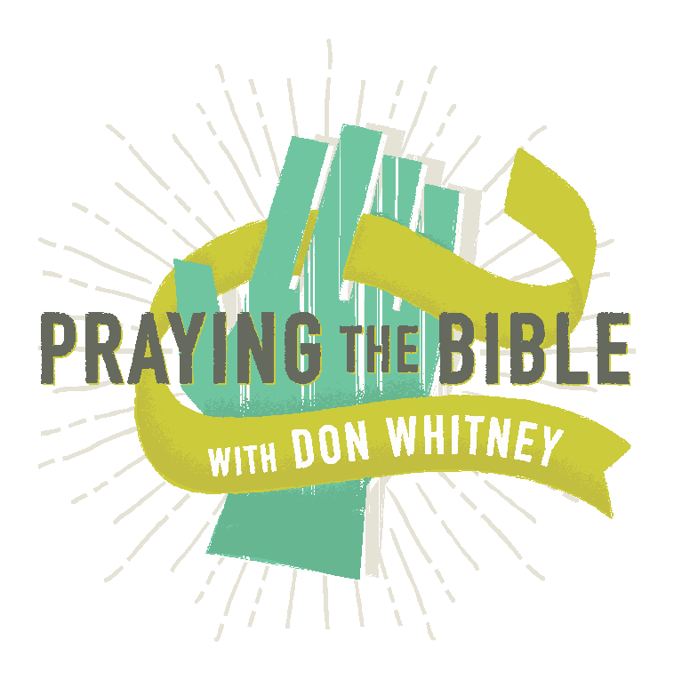


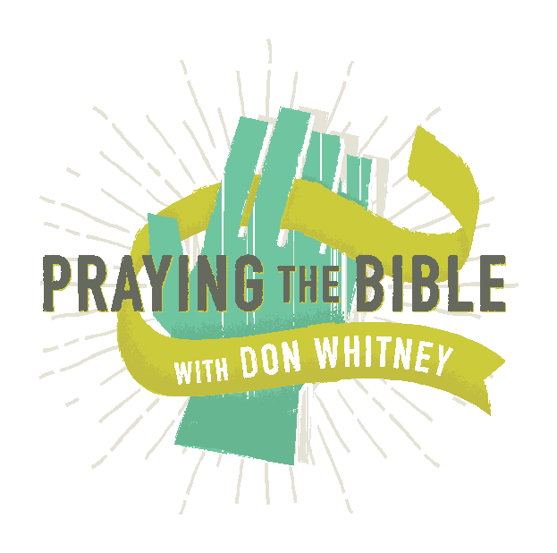
We all want to pray, but sometimes it’s hard to know where to start. One helpful approach is to pray through the Psalms.
DAY 1  Psalm 1  Psalm 31  Psalm 61  Psalm 91  Psalm 121 | DAY 2  Psalm 2  Psalm 32  Psalm 62  Psalm 92  Psalm 122 | DAY 3  Psalm 3  Psalm 33  Psalm 63  Psalm 93  Psalm 123 | DAY 4  Psalm 4  Psalm 34  Psalm 64  Psalm 94  Psalm 124 | DAY 5  Psalm 5  Psalm 35  Psalm 65  Psalm 95  Psalm 125 | DAY 6  Psalm 6  Psalm 36  Psalm 66  Psalm 96  Psalm 126
DAY 7  Psalm 7  Psalm 37  Psalm 67  Psalm 97  Psalm 127 | DAY 8  Psalm 8  Psalm 38  Psalm 68  Psalm 98  Psalm 128 | DAY 9  Psalm 9  Psalm 39  Psalm 69  Psalm 99  Psalm 129 | DAY 10  Psalm 10  Psalm 40  Psalm 70  Psalm 100  Psalm 130 | DAY 11  Psalm 11  Psalm 41  Psalm 71  Psalm 101  Psalm 131 | DAY 12  Psalm 12  Psalm 42  Psalm 72  Psalm 102  Psalm 132
DAY 13  Psalm 13  Psalm 43  Psalm 73  Psalm 103  Psalm 133 | DAY 14  Psalm 14  Psalm 44  Psalm 74  Psalm 104  Psalm 134 | 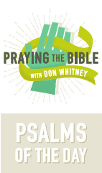 |  | DAY 15  Psalm 15  Psalm 45  Psalm 75  Psalm 105  Psalm 135 | DAY 16  Psalm 16  Psalm 46  Psalm 76  Psalm 106  Psalm 136
DAY 17  Psalm 17  Psalm 47  Psalm 77  Psalm 107  Psalm 137 | DAY 18  Psalm 18  Psalm 48  Psalm 78  Psalm 108  Psalm 138 |  |  | DAY 19  Psalm 19  Psalm 49  Psalm 79  Psalm 109  Psalm 139 | DAY 20  Psalm 20  Psalm 50  Psalm 80  Psalm 110  Psalm 140
DAY 21  Psalm 21  Psalm 51  Psalm 81  Psalm 111  Psalm 141 | DAY 22  Psalm 22  Psalm 52  Psalm 82  Psalm 112  Psalm 142 | DAY 23  Psalm 23  Psalm 53  Psalm 83  Psalm 113  Psalm 143 | DAY 24  Psalm 24  Psalm 54  Psalm 84  Psalm 114  Psalm 144 | DAY 25  Psalm 25  Psalm 55  Psalm 85  Psalm 115  Psalm 145 | DAY 26  Psalm 26  Psalm 56  Psalm 86  Psalm 116  Psalm 146
DAY 27  Psalm 27  Psalm 57  Psalm 87  Psalm 117  Psalm 147 | DAY 28  Psalm 28  Psalm 58  Psalm 88  Psalm 118  Psalm 148 | DAY 29  Psalm 29  Psalm 59  Psalm 89  Psalm 119  Psalm 149 | DAY 30  Psalm 30  Psalm 60  Psalm 90  Psalm 120  Psalm 150 | DAY 31  Psalm 119

Insert this chart into the back of your Bible, using it as a tool to
help you pick a new psalm to pray through each and every day. Don’t feel pressure to pray through every psalm listed for each day; simply choose whichever one seems most relevant in the moment.

* Wrapping It Up

Praying the Bible is just one method of focusing your prayers to the Lord. You may be interested to do a study or listen to a sermon series on what is known as The Lord’s Prayer in Matthew 6:9-13 and Luke 11:1-4. This is the passage where Jesus shares with His disciples how to pray. Alistair Begg has a sermon series on Luke 11 available online or for purchase titled “When You Pray, Say: Finding Instruction in the Lord’s Prayer”. You can listen online for free at https://www.truthforlife.org/resources/series/when-you-pray-say/ or call Truth for Life ministry and order by calling (888) 588-7884 (M-F 8:00am to 5:00pm ET).

Donald Whitney’s little book, Praying the Bible is also available in hardback, audio, and Kindle versions. It is very practical and gives a fuller explanation of this method along with plenty more examples.

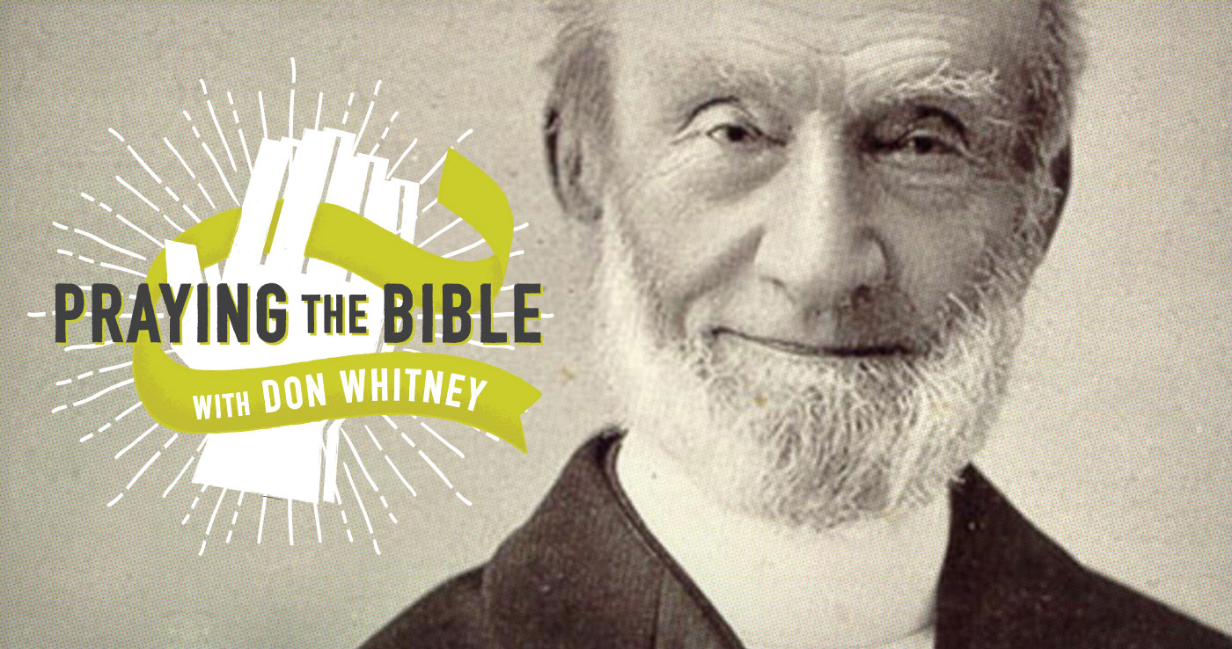
What George Mueller Can Teach Us about Prayer
George Mueller (1805–1898) is widely considered one the greatest men of prayer and faith since the days of the New Testament. He lived nearly the entire nineteenth century, two-thirds of it in Bristol, England. He led four far-reaching, influential ministries, but we know him best today for his orphanages.

During a time in England when most orphans lived in miserable workhouses or on the streets, like Charles Dickens’s Oliver Twist, Mueller took them in, fed them, clothed them, and educated them. Through his orphanage in Bristol, Mueller cared for as many as two thousand orphans at a time—more than ten thousand in his lifetime. Yet he never made the needs of his ministries known to anyone except to God in prayer. Only through his annual reports did people learn after the fact what the needs had been during the previous year and how God had provided.

Mueller had over fifty thousand specific recorded answers to prayers in his journals, thirty thousand of which he said were answered the same day or the same hour that he prayed them. Think of it: that’s five hundred definite answers to prayer each year—more than one per day—every single day for sixty years! God funneled over half a billion dollars (in today’s dollars) through his hands in answer to prayer.
Mueller’s Great Discovery

How did George Mueller pray? He said that for the first ten years of what he called his “life of faith”—referring not to when he was unknown but to ten years of trust in God and remarkable answers to prayer—he often struggled to get into the spirit of prayer, in other words, to really feel like praying. Until, that is, he made one slight alteration in his method. Here’s how he described the change:

The difference, then, between my former practice and my present one is this: formerly, when I rose, I began to pray as soon as possible, and generally spent all my time till breakfast in prayer, or almost all the time. At all events I almost invariably began with prayer. . . . But what was the result? I often spent a quarter of an hour, or half an hour, or even an hour on my knees before being conscious to myself of having derived comfort, encouragement, humbling of soul, etc.; and often, after having suffered much from wandering of mind for the first ten minutes, or quarter of an hour, or even half an hour, I only then really began to pray.I scarcely ever suffer now in this way. For my heart being nourished by the truth, being brought into experimental [today we would say “experiential”] fellowship with God, I speak to my Father and to my Friend (vile though I am, and unworthy of it) about the things that He has brought before me in His precious Word. It often now astonishes me that I did not sooner see this point.

So Mueller would sometimes flounder for half an hour to an hour trying to pray, fighting to focus his thoughts and to kindle feelings for prayer in his heart. Only after that long, determined struggle would he finally enter into a sense of communion with God. But once he began the practice of conversing with God about what he found in the Word of God, he “scarcely ever” suffered with those problems in prayer again. Praying through a passage of Scripture as he went “walking about in the fields” was the uncomplicated method that transformed the daily experience of one of the most famous men of prayer in history.

And it can transform your prayer life just as easily. https://www.crossway.org/blog/2015/07/what-george-mueller-can-teach-us-about-prayer/

